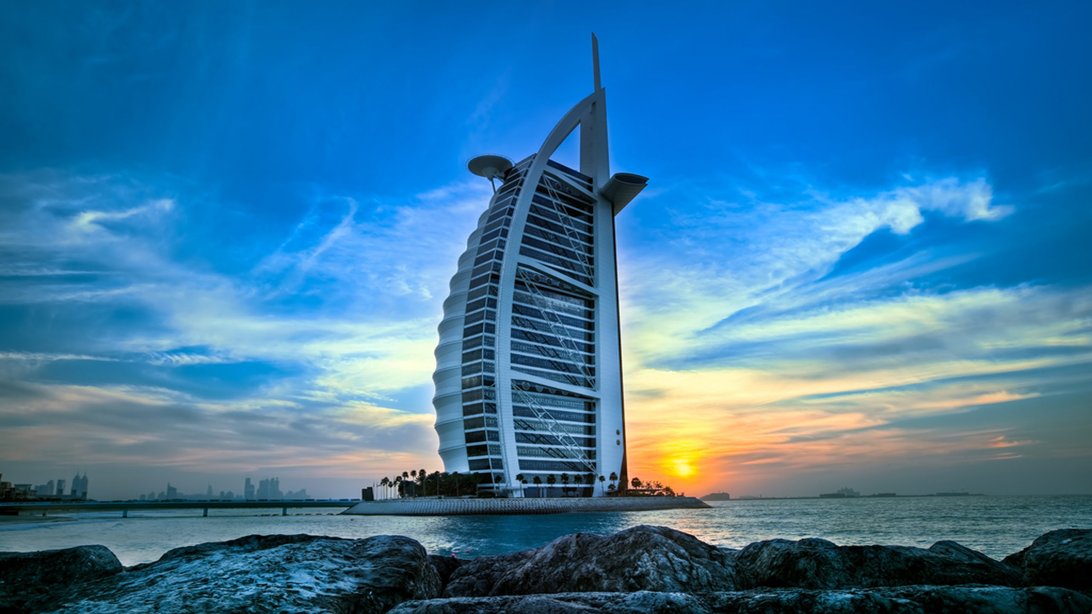

HARVARD
MODEL
CONGRESS
DUBAI

2018

Contents
Welcome 2
Conference Schedule 3
Committee Locations 4
Campus Map 5
Conference Staff 6
Participating Schools 7
Badge and Placard Guide 8
Bill/Resolution Template 9
Guidelines for Student Conduct 10
Campus Evacuation Procedures 11
Acknowledgements 12
Parliamentary Procedure Table 13

info@hmcdubai.org • www.hmcdubai.org

Benjamin Delsman
President
Dear Delegates and Faculty Advisors,
18th January, 2018

Isabella Huber
Vice President

Sean Henson
Director of Operations

Cate Pinto
Faculty Liaison

Sophie Schick
Director of Programs

William Delaney
Director of Outreach

Shing-Shing Cao
Business Manager

Sally Yi
Chief of Staff

It is my great honor to invite you to Harvard Model Congress Dubai 2018, our sixth annual conference. This coming January, delegates will gather from around the world to learn about complex political and policy challenges—both domestic and international—and then debate those issues with their peers. This is a tall order, but we have consistently attracted remarkable delegates capable of meeting these challenges, and our exceptional staff of Harvard undergraduates will be there to guide them every step of the way. From formal committee sessions to one-on-one conversations, delegates will have a diverse range of opportunities to learn from our knowledgeable, passionate staff. Historically, delegates have had a lot of fun, too.
At its core, Harvard Model Congress is a teaching organization. Due to our immersive simulation structure, students learn immediately applicable skills in an interactive way. And while our students certainly learn the things one would expect a government simulation to teach—parliamentary procedure, bill-writing, debate—their growth at HMC goes far beyond these areas. At the end of the conferences, delegates tell our staffers about how much their English public speaking abilities have improved, or how they’ve learned to see political debates from a new perspective, or how their confidence has grown. We staff HMC Dubai for moments like these, and we’re excited to do it again.
Our 2017 conference was our largest yet, and we’re eager to build on that success this year. We’re bringing more Harvard students to maintain our low delegate-to-staff ratio, we’re developing new educational materials to ensure delegates are prepared for the conference, and we’re continuing to refine our committee offerings to ensure we’re bringing you into the most engaging, timely discussions. If you’re interested in Harvard Model Congress Dubai, or if you have any questions, please reach out to our Faculty Liaison, Cate Pinto, at info@hmcdubai.org.
Our mission is to inspire students toward civic engagement and give them the skills to improve our shared world. We hope you’ll join us in doing so at HMC Dubai 2018!
Sincerely,

Benjamin Delsman
HMCD President

Conference Schedule
Thursday, JANUARY 18th
12:00 PM – 10:00 PM | Conference Services Open | C-404
1:30 PM – 4:00 PM | Registration | Admin Building Foyer
4:00 PM – 5:00 PM | Opening Ceremonies | Auditorium (Admin Building)
5:00 PM – 8:00 PM | Committee Meetings for All Programs | See Page 4
8:00 PM – 10:00 PM  FRIDAY, JANUARY 19th | Delegate Meet & Greet Social and Dinner | Lawn Behind E Building
8:15 AM – 12:00 PM | Committee Meetings for All Programs | See Page 4
12:00 PM – 1:00 PM | Lunch | Lawn behind E-building
1:00 PM – 3:00 PM | Full Sessions and International Summit  Committee Meetings for CIA and UNSC | See Page 4
3:00 PM – 4:00 PM  4:00 PM – 7:00 PM  SATURDAY, JANUARY 20th | Harvard-AUD College Panel  Committee Meetings for All Programs | Auditorium (Admin Building)  See Page 4
9:00 AM – 12:00 PM | Full Sessions and International Summit  Committee Meetings for CIA and UNSC | See Page 4
12:00 PM – 12:50 PM | Committee Meetings for All Programs | See Page 4
1:00 PM – 2:00 PM | Closing Ceremonies | Auditorium (Admin Building)

Committee Locations
Admin
Auditorium Foyer – Registration
Auditorium – Opening Ceremonies, Closing Ceremonies

B-Building
B104 – House Energy and the Workforce
B105 – House Homeland Security
B106 – House Science, Space, and Technology

C-Building
C220 – Faculty Lounge
C227 – Full House Session
C307 – Arab League
C308 – African Union
C341 – World Health Organization
C404 – Conference Services
C407 – CIA
C408 – World Bank
C410 – UN Security Council

E-Building
E109 – Full Senate Session
E421 – International Summit
E401 – Senate Foreign Relations
E414 – Senate Intelligence
E416 – Senate Health, Education, Labor and Pensions

Campus Map

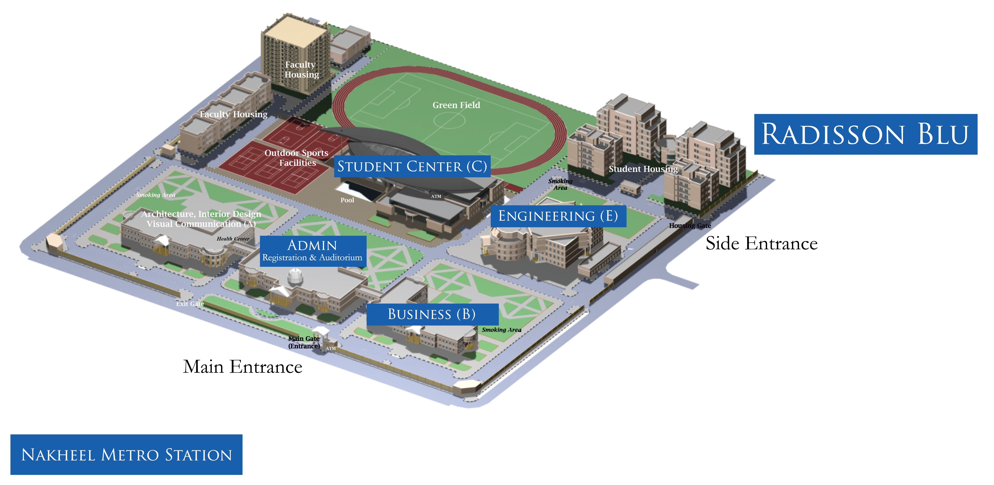

Building Names
Administration: Admin Building
School of Architecture, Art and Design: A-building
School of Architecture, Art and Design Annex: A-building Annex or “The Extension” School of Business Administration: B-building
The Student Center: C-building School of Engineering: E-building Student Housing: Dorms

Conference Staff

African Union
Matt Keating & Lainey Newman
africanunion.hmcd@gmail.com

Arab League
Lyndon Hanrahan & Danielle Roybal
arableague.hmcd@gmail.com

CIA
Nick Pagel & Caleb Esrig
cia.hmcd@gmail.com

Senate HELP
Jeewon Lee and Adam Harper
senatehelp.hmcd@gmail.com

United Nations Security Council
Narayan Narasimhan & Yankang Yang
unsc.hmcd@gmail.com

World Bank
Pranay Nadella & Joshua Lee
worldbank.hmcd@gmail.com

House Education and the Workforce (E&W)
Cass Hastie and Audrey Mustoe
houseEW.hmcd@gmail.com

House Homeland Security
Gene Chang and Michael Wornow
househomeland.hmcd@gmail.com

House Science, Space,
and Technology (SST)
Ben Porter and Raymond Wang
housesst.hmcd@gmail.com

Presidential Cabinet
Archana Somasegar & Danielle Foltz
prescab.hmcd@gmail.com

Senate Foreign Relations
Dustin Chiang and Charlotte Davis
senatefr.hmcd@gmail.com

Senate Intelligence
Nida Ansari & Rachel Chiu
Senateintel.hmcd@gmail.com

Participating Schools

Will be updated as registration draws to a close.

Badge & Placard Guide
STATE ABBREVIATIONS

AL | Alabama | LA | Louisiana | OH | Ohio
AK | Alaska | ME | Maine | OK | Oklahoma
AZ | Arizona | MD | Maryland | OR | Oregon
AR | Arkansas | MA | Massachusetts | PA | Pennsylvania
CA | California | MI | Michigan | RI | Rhode Island
CO | Colorado | MN | Minnesota | SC | South Carolina
CT | Connecticut | MS | Mississippi | SD | South Dakota
DE | Delaware | MO | Missouri | TN | Tennessee
FL | Florida | MT | Montana | TX | Texas
GA | Georgia | NE | Nebraska | UT | Utah
HI | Hawaii | NV | Nevada | VT | Vermont
ID | Idaho | NH | New Hampshire | VA | Virginia
IL | Illinois | NJ | New Jersey | WA | Washington
IN | Indiana | NM | New Mexico | WV | West Virginia
IA | Iowa | NY | New York | WI | Wisconsin
KS | Kansas | NC | North Carolina | WY | Wyoming
KY | Kentucky | ND | North Dakota

ABBREVIATIONS
AL: Member-at-Large
SR: Senior Senator
JR: Junior Senator
D: Democrat
R: Republican
I: Independent

Bill/Resolution Template

A bill or resolution should include:

Enactment Clause: “Be It Hereby Enacted by the [COMMITTEE NAME]:” This clause gives a bill/resolution the full legal authority of the body proposing it.

Preamble: The Preamble should be a one to two statement of purpose that briefly states what the bill seeks to accomplish and how it would do so.

Content: This section of a bill or resolution enumerates the specific actions that the document will mandate. Content clauses should be positive and not normative in nature – that is, they should accomplish something definitive (i.e. allocations, authorizations, etc.) Normative language should be kept in the preamble.

Definitions: Any technical terms, as well as the abbreviations of any organizations or departments referred to in the text of the bill/resolution, should be defined and included in this section. Any ambiguous phrases should also be explained further in the definitions section.

Enforcement: The legislation must also explain who in the government (e.g. department, agency) or international community (e.g. UN body, non-governmental organization) will be responsible for the implementation of the bill/resolution. If any monitoring, supervision or review is required, the party or parties responsible for doing so should also be listed in this section.

Enactment: This sets the number of days until a passed bill/resolution goes into effect, typically 91 days.

Funding: If the bill/resolution allocates funds for certain projects, creates a new agency, or calls for any kind of reorganization that would require that money be spent, the bill must specify where the money will come from.

Authors: This section lists the authors of the bill/resolution.

Signatories: This lists those who would like to see the bill/resolution introduced for debate. Each bill/resolution must have a minimum number of signatories to be introduced, which will be determined at the Chair’s discretion.

Code of Conduct
HMCD 2017 participants must take the issue of security very seriously to ensure a safe and successful conference. Every member of each delegation should be fully aware of and abide by these Guidelines for Student Conduct.

- — We have two primary security concerns: student safety and host property. If you are responsible for any malicious damage to AUD property, or endanger your own safety or the safety of any other person at AUD, you and your entire delegation will immediately be expelled from the conference without financial compensation from HMCD. Each delegate will be held legally and financially responsible for any damage to AUD property. University management may choose to prosecute people who damage property in any way.

- — Smoking is prohibited by HMCD at all times during the conference. Students may not possess drugs or alcohol at any time during the three days of the conference. Conference security will have the authority to confiscate any drugs or liquor in the possession of any HMCD delegate. Delegates found to possess or use drugs or alcohol will be required to leave immediately and may be held criminally liable.

- — Theft of AUD, student, or other property is unacceptable and will not be tolerated.

- — Proper attire is vital to maintaining a high degree of professionalism and the atmosphere of our conference. During the conference, HMCD staff will enforce the dress code for delegates. No jeans, sneakers, T-shirts, or baseball caps shall be worn in committee. All students should dress in a professional manner. Women should wear a suit, dress, dress pants, or skirt with blouse or sweater. Men should wear a suit or a jacket and dress pants, with a dress shirt and tie. Traditional attire that would commonly replace the specified formal attire is also welcomed. Students who do not obey the dress code will be required to change their attire.

- —Students must wear their conference badges at all times for their own safety and for identification purposes.

The above rules supplement those dictated by existing codes of law in the UAE, laws and ordinances of the city of Dubai, AUD policy, your school policy, and common sense. Violation of any of the above rules will normally result in the expulsion of the student(s) involved and their entire school delegation without financial compensation from HMCD. Harvard Model Congress Dubai 2017 cannot accept any liability; faculty advisors are responsible for the actions of their students, though ultimate responsibility rests with the students themselves.
Campus Evacuation Procedures
In all buildings, elevators must not be used in case of emergency evacuation.

Administration (Admin Building): When the fire alarms sound, building occupants must evacuate immediately through either the ground floor main entrance near the main reception or through the two side exits opposite the School of Architecture, Art and Design, and the School of Business Administration Academic buildings. Individuals on the second floor can either use the main stairs and exit through the ground floor main entrance or use the bridges to the School of Architecture, Art and Design, and the School of Business Administration Academic buildings go down the closest staircase and exit through the nearest building exit. All should assemble at the meeting point on the soccer field.

School of Architecture, Art and Design (A-building): Individuals should use the main and side exits of the building; those on the second floor should use the staircases and exit through the closest exit, either the main or side doors, and assemble at the meeting point on the soccer field.

School of Architecture, Art and Design Annex (A-building Annex, “The Extension”): Individuals should use the main exit of the building or through the VC and the ID labs; they both have emergency exits, and assemble at any of the meeting points in the soccer field or the main students’ car park.

School of Business Administration (B-building): Individuals should use the main and side exits of the building; those on the second floor should use the staircases and exit through the closest exit, either the main or side doors, and assemble at the meeting point on the soccer field.

The Student Center (C-building): Occupants should use the main and side exits of the building on the first floor. Those on the second floor should use any of the fire exits stair cases located in the Food Court or next to the Gymnasium; also they can use the main stair case of the building leading to the main entrance. Those on the third and the fourth floors should use any of the two fire exit stair cases located in the classrooms/labs wing and the other in the offices wing to the ground floor, and from there through any emergency exits or the main entrances and assemble at the meeting point on the soccer field.

School of Engineering (E-building): Occupants should use the main and side exits of the building on the first floor. Those on the second floor should use the main staircases on the right and left sides
of the building. Those on floors 3-4 should use the staircase exits to the ground floor. All should assemble at the meeting point on the soccer field.

Student Housing (Dorms): Residents from all floors should use the closest stairs and exit through any of the building exits or main doors and assemble at the meeting point on the soccer field.
Faculty Housing. Residents should use the closest stairs to exit the building and assemble at the meeting point on the soccer field.

Important Safety Issues: Fire Extinguishers are not for propping doors open; they should be left where they are. For more detailed exit procedures, please read evacuation notices in each building where exact exit routes are posted.

Acknowledgements

Harvard Model Congress Dubai would especially like to thank the American University in Dubai, and our partners from AUD Model United Nations for their incredible talent, dedication, and hospitality. This conference is possible thanks to their support and collaboration. They have truly been instrumental in making HMCD possible for five consecutive years.

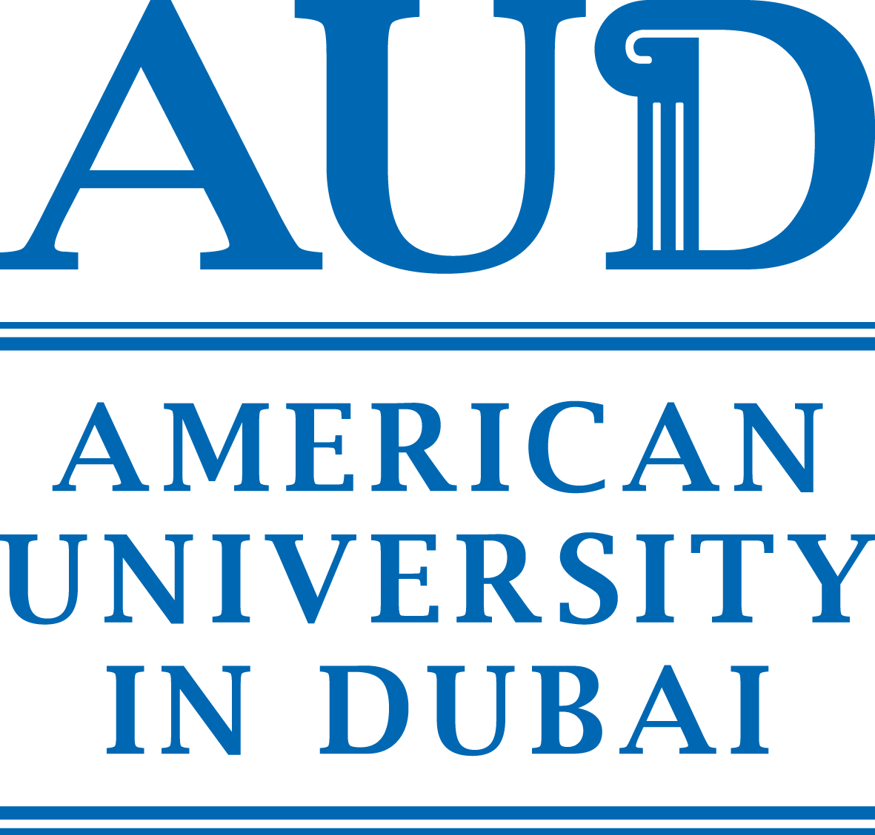

We would want to especially thank and acknowledge the following individuals from AUD and AUDMUN, with whom we have been working directly for the past few months in preparation for HMCD 2018:
Peggy M. Awad – AUD Director of External Relations
Sara Sleem – AUD Assistant Director of Admissions
Farah Ali – AUDMUN President
Other AUDMUN members

Signatures: | Committee Bill | Committee Amendment | Full Session Amendment
House | 10 | 5 | 20
Senate | 6 | 3 | 12
Note: Numbers are subject to change based on committee size.
Table of Motions
Motion | Type | Second | Debate | Vote | Notes
Adjourn | P | Yes | No | Maj. | Chair
Amend | S | Yes | Yes | Maj.
Appeal | I | Yes | Chair | Maj.
Caucus | P | Yes | No | Maj. | State time/type
Cloture | S | Yes | No | 3/5 | Of all members
Divide the question | I | Yes | No | Maj. | Chair
General speakers’ list (be added to) | M | No | No | None | Chair
Introduce a bill or resolution | M | Yes | 1 Pro  1 Con | 1/3
Lay on table | S | Yes | No | Maj.
Object to the consideration | I | No | No | 2/3
Parliamentary inquiry | I | No | No | None
Personal privilege | I | No | No | None
Point of order | I | No | No | None
Previous question | S | Yes | No | 2/3
Pro/con speakers’ list (be added to) | S | No | No | None | Chair  State pro or con
Recess | P | Yes | No | Maj. | Chair
Reconsider | R | Yes | Yes | Maj. | Must be made by the “winner”
Request for information | I | No | No | None
Set the agenda | M | Yes | No | Maj. | Chair
Suspend the rules | I | Yes | No | 2/3 | Chair
Take from table | R | Yes | Yes | Maj.

“M” = Main; “S” = Subsidiary; “I” = Incidental; “P” = Privileged;
“R” = Restoratory; “Maj.” = Simple Majority
Approval is required for all motions with note “Chair”
No appeal allowed:
- Dilatory motions
- Signature counts
- All motions requiring chair approval
Table of Precedence
Adjourn
Recess
Caucus
Incidental
Motions
Lay on the Table
Previous Question/Cloture
Amend
Pro/Con Speakers’ List
Main and Restoratory Motions
Above: The motions, with highest precedence at the top and lowest at the bottom.
Motions with lower precedence cannot be made without first settling a motion of higher precedence.
Note that no main or restoratory motion may be introduced while another is pending, and incidental motions may be applied only when relevant.

